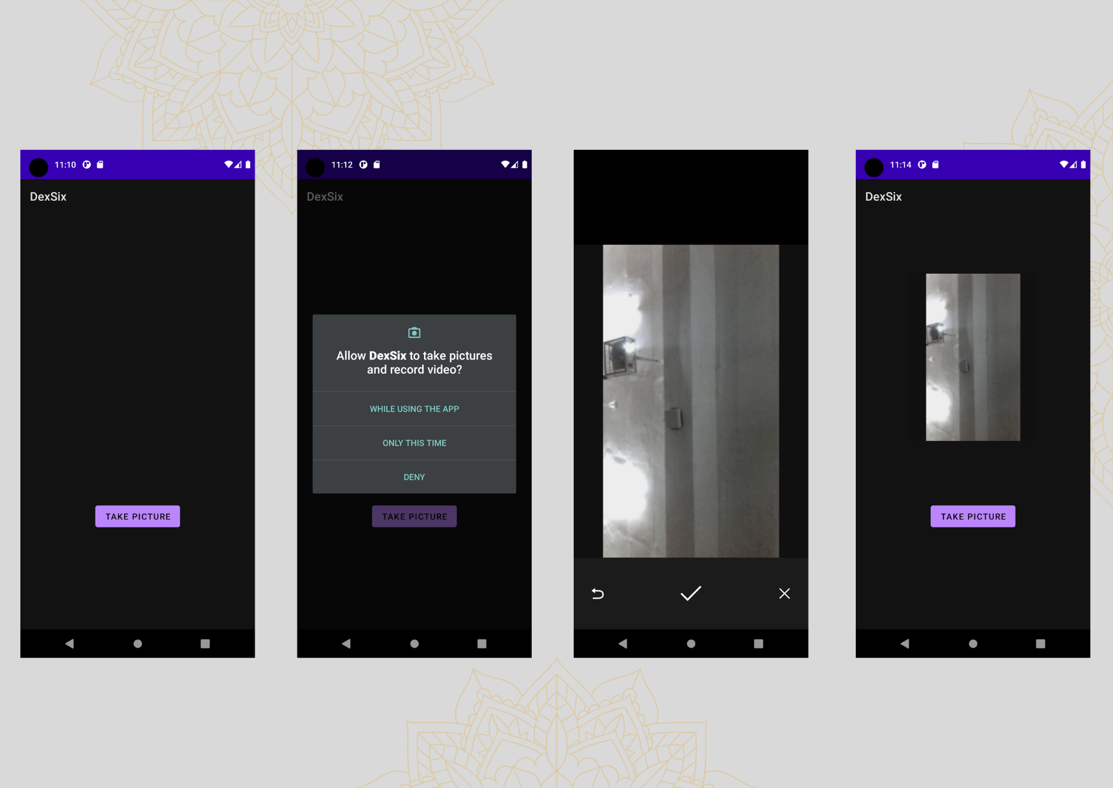

Give permission In mainfest

<uses-permission android:name="android.permission.CAMERA" />

package alpha.dex.dexsix

import android.app.Activity

import android.content.Intent

import android.content.pm.PackageManager

import android.graphics.Bitmap

import androidx.appcompat.app.AppCompatActivity

import android.os.Bundle

import android.provider.MediaStore

import android.widget.Button

import android.widget.ImageView

import android.widget.Toast

import androidx.activity.result.ActivityResultLauncher

import androidx.activity.result.contract.ActivityResultContracts

import androidx.core.content.ContextCompat

class CameraPicture : AppCompatActivity() {

lateinit var requestCamera: ActivityResultLauncher<String>

lateinit var imageCapture: ActivityResultLauncher<Intent>

override fun onCreate(savedInstanceState: Bundle?) {

super.onCreate(savedInstanceState)

setContentView(R.layout.activity_camera_picture)

var btnCamera = findViewById<Button>(R.id.btnCamera)

requestCamera = registerForActivityResult(ActivityResultContracts.RequestPermission())

{

if (it) {

Toast.makeText(applicationContext, "Permission Granted", Toast.LENGTH_LONG).show()

cameraCall()

} else

Toast.makeText(applicationContext, "Permission Denied", Toast.LENGTH_LONG).show()

}

imageCapture =

registerForActivityResult(ActivityResultContracts.StartActivityForResult())

{

if (it.resultCode == Activity.RESULT_OK) {

handleCameraImage(it.data)

}

}

btnCamera.setOnClickListener {

callPermission()

}

}

fun cameraCall() {

val camera_intent = Intent(MediaStore.ACTION_IMAGE_CAPTURE)

imageCapture.launch(camera_intent)

}

fun handleCameraImage(intent: Intent?) {

var imageCamera = findViewById<ImageView>(R.id.imageCamera)

val bitmap = intent?.extras?.get("data") as Bitmap

imageCamera.setImageBitmap(bitmap)

}

fun callPermission() {

when {

ContextCompat.checkSelfPermission(this, android.Manifest.permission.CAMERA)

== PackageManager.PERMISSION_GRANTED -> {

Toast.makeText(applicationContext, "Permission Granted Already", Toast.LENGTH_LONG)

.show()

cameraCall()

}

else -> {

requestCamera.launch(android.Manifest.permission.CAMERA)

}

}

}

}

Xml file

<?xml version="1.0" encoding="utf-8"?>

<androidx.constraintlayout.widget.ConstraintLayout xmlns:android="http://schemas.android.com/apk/res/android"

xmlns:app="http://schemas.android.com/apk/res-auto"

xmlns:tools="http://schemas.android.com/tools"

android:layout_width="match_parent"

android:layout_height="match_parent"

tools:context=".CameraPicture">

<Button

android:id="@+id/btnCamera"

android:layout_width="wrap_content"

android:layout_height="wrap_content"

android:text="Take Picture"

app:layout_constraintBottom_toBottomOf="parent"

app:layout_constraintEnd_toEndOf="parent"

app:layout_constraintStart_toStartOf="parent"

app:layout_constraintTop_toTopOf="parent"

app:layout_constraintVertical_bias="0.746" />

<ImageView

android:id="@+id/imageCamera"

android:layout_width="252dp"

android:layout_height="280dp"

app:layout_constraintBottom_toTopOf="@+id/btnCamera"

app:layout_constraintEnd_toEndOf="parent"

app:layout_constraintStart_toStartOf="parent"

app:layout_constraintTop_toTopOf="parent" />

</androidx.constraintlayout.widget.ConstraintLayout>